**Variation Agreement**

TO: Alex Xiao REV: 01

FROM: Felix Ye

PROJECT: 589-591 Elizabeth Street, Redfern DATE: 19 October 2022

SUBJECT: Variation Agreement of services

**The to confirm the extra work for services we engaged for deletion of basement car park. Details as per below:**

|  |  |  |  |  |  |
| --- | --- | --- | --- | --- | --- |
| **Mechanical** |  |  |  |  |  |
| Variation of coordination due to basement deletion | | | | | $ 2,250 |
| **Electrical** |  |  |  |  |  |
| Variation of coordination due to basement deletion | | | | | $ 2,250 |
| **Hydraulic** |  |  |  |  |  |
| Variation of coordination due to basement deletion | | | | | $ 2,250 |
| **Fire Service** |  |  |  |  |  |
| Variation of coordination due to basement deletion | | | | | $ 1,500 |

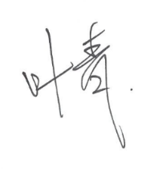Yours faithfully

**Qing (Felix) Ye**

**Director**

**Mechanical Engineer**

**M.E.  CPEng   NER  RPEQ**